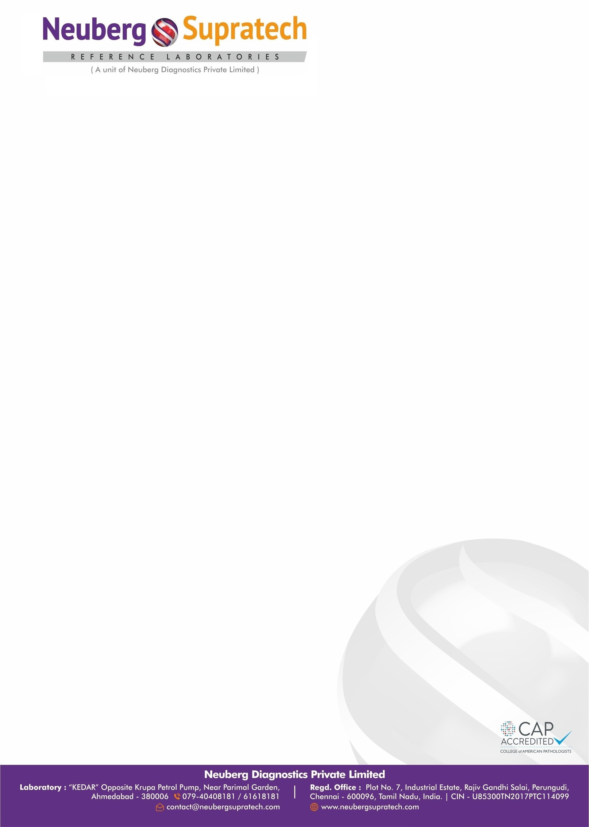
Interpretation
Dried blood spot analysis shows no abnormality detected in Amino acid profile and acyl carnitine profile.

Remarks | Please correlate results with clinical history, other laboratory findings, and medication given to the patient.

Limitations :
- Σομε φορμσ (γενοτψπεσ) οφ τηεσε δισορδερσ μαψ νοτ βε δετεχτεδ βψ νεοναταλ σχρεενινγ ορ μαψ νοτ βε δετεχτεδ ιν νεωβορν δριεδ βλοδ σποτσ. • Νεωβορν σχρεεν φινδινγσ χαν ρεϖεαλ ματερναλ δεφεχτσ ιν τηε χασε οφ σεϖεραλ ινβορν ερρορσ οφ μεταβολισμ, ινχλυδινγ 3− μετηψλχροτονψλΧοΑ χαρβοξψλασε δεφιχιενχ
y and carnitine transport defect, and can reveal nutritional deficits in the mother. • Newborn screening is designed to accept an increased false-positive rate to have an excellent sensitivity and negative predictive value. • Some of the values might get altered in case of drugs taken prior to testing, hence considered during interpretation of data. • A normal profile does not rule out inborn error of metabolism.
Notes :
- ΜΣ/ΜΣ σχρεεν ονλψ

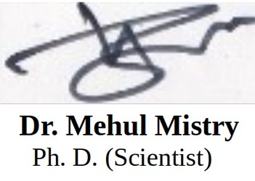
MD Pathology

Test Result
1. Amino acids metabolites :

Sr. No. | Metabolite Name | Control Value | Observed Value | Column 5 | Sr. No._2 | Metabolite Name_2 | Control Value_2 | Observed  Value
1 | Alanine | 0 - 1000 | 287.57 |  | 6 | Methionine | 0 - 75 | 16.2
2 | Arginine | 0 - 110 | 20.29 |  | 7 | Ornithine | 0 - 450 | 38.5
3 | Citrulline | 3 - 75 | 7.71 |  | 8 | Phenylalanine | 0 - 155 | 33.96
4 | Glycine | 0 - 750 | 196.47 |  | 9 | Tyrosine | 0 - 350 | 41.72
5 | Leucine-lsoleucine | 0 - 375 | 112.47 |  | 10 | Valine | 0 - 325 | 66.99

2. Fatty acids metabolites :

Sr. No. | Metabolite Name | Control Value | Observed Value | Column 5 | Sr. No._2 | Metabolite Name_2 | Control Value_2 | Observed  Value
1 | C0 | 0 - 125 | 21.95 |  | 16 | C10:2 | 0 - 0.22 | 0.03
2 | C2 | 0 - 150 | 10.75 |  | 17 | C12 | 0 - 0.9 | 0.05
3 | C3 | 0 - 6.3 | 0.65 |  | 18 | C12:1 | 0 - 0.51 | 0.07
4 | C4 | 0 - 1.7 | 0.21 |  | 19 | C14 | 0 - 1.2 | 0.07
5 | C4OH | 0 - 0.8 | 0.09 |  | 20 | C14:1 | 0 - 0.8 | 0.02
6 | C4DC | 0 - 1.29 | 0.09 |  | 21 | C14-OH | 0 - 0.2 | 0.02
7 | C5 | 0 - 1.0 | 0.12 |  | 22 | C14:2 | 0 - 0.14 | 0.01
8 | C5:1 | 0 - 0.9 | 0.03 |  | 23 | C16 | 0 - 10 | 0.45
9 | C5-OH | 0 - 1 | 0.06 |  | 24 | C16:1 | 0 - 1.4 | 0.04
10 | C5DC | 0 - 0.6 | 0.08 |  | 25 | C16OH | 0 - 0.13 | 0.01
11 | C6 | 0 - 0.95 | 0.08 |  | 26 | C18 | 0 - 4 | 0.18
12 | C8 | 0 - 0.6 | 0.24 |  | 27 | C18:1 | 0 - 7 | 0.28
13 | C8:1 | 0 - 0.7 | 0.19 |  | 28 | C18:2 | 0 - 0.1 | 0.08
14 | C10 | 0 - 0.65 | 0.04 |  | 29 | C18:1OH | 0 - 0.1 | 0.01
15 | C10:1 | 0 - 0.45 | 0.06 |  | 30 | C18OH | 0 - 0.1 | 0.01

Annexure 1
DISORDERS DETECTED BY TANDEM MASS SPECTROMETRY

Acylcarnitines profile | Fatty acid oxidation disorder

- Beta-Ketothiolase deficiency (BKT)/ Mitochondrial acetoacetyl- CoA Thiolase deficiency • Glutaric acidemia type I (GA1) • Holocarboxylase synthase deficiency (MCD)/ Multiple Co-A carboxylase deficiency • 3-Hydroxy-3-methyglutaric aciduria (HMG)/3-hydroxy-3- methylglutaryl-CoA lyase deficiency • Isovaleric acidemia (IVA) • 3-Methylcrotonyl-CoA carboxylase deficiency (3-MCC) • Propionic acidemia (PROP) • 2-Methyl-3-hydroxybutyric aciduria (2M3HBA) • 2-Methylbutyrylglycinuria (2MBG) • 3-Methylglutaconic aciduria (3MGA) • Isobutyrylglycinuria (IBG) • Malonic acidemia (MAL) • Methylmalonic acidemia (cobalamin disorders) • Methylmalonic acidemia (methylmalonyl-CoA mutase) • Methylmalonic acidemia with homocystinuria (Cbl C,D) • Vitamin B12-responsive methylmalonic aciduria
- Carnitine uptake defect/carnitine transport defect (CUD) • Long-chain L-3 hydroxyacyl-CoA dehydrogenase deficiency (LCHAD) • Medium-chain acyl-CoA dehydrogenase deficiency (MCAD) • Trifunctional protein deficiency (TFP) • Very long-chain acyl-CoA dehydrogenase deficiency (VLCAD) • 2,4 Dienoyl-CoA reductase deficiency (DE RED) • Carnitine acylcarnitine translocase deficiency (CACT) • Carnitine palmitoyltransferase type I deficiency (CPT IA) • Carnitine palmitoyltransferase type II deficiency (CPT II) • Glutaric acidemia type II (GA2)/ Multiple Acyl-CoA dehydrogenase deficiency • Medium-chain ketoacyl-CoA thiolase deficiency (MCAT) • Medium/short-chain L-3-hydroxyacyl-CoA dehydrogenase deficiency (M/SCHAD) • Short-chain acyl-CoA dehydrogenase deficiency (SCAD)

Metabolic Disorder | Amino acid disorder

Other Disorder
- Λιϖερ Δισεασε • Τρεατμεντ ωιτη Βενζοατε, Πψϖαλιχ Αχιδ, ορ ςαλπροιχ Αχιδ • Τοταλ παρεντεραλ νυτριτιον (ΤΠΝ)/Ηψπεραλιμεντατιον • Μεδιυμ Χηαιν Τριγλψχεριδε Οιλ Αδμινιστρατιον • Πρεσενχε οφ ΕΔΤΑ Αντιχοαγυλαντσ ιν βλοοδ σπεχιμεν

TEST RESULTS UNIT BIOLOGICAL REF RANGE REMARKS
New born Screening test- Acylcarnitine Analytes
C0 µmol/L 0 - 125 21.95
C2 µmol/L 0 - 150 10.75
C3 µmol/L 0 - 6.3 0.65
C4 µmol/L 0 - 1.7 0.21
C4OH µmol/L 0 - 0.8 0.09
C4DC µmol/L 0 - 1.29 0.09
C5 µmol/L 0 - 1.0 0.12

C5 | 1

C5-OH µmol/L 0 - 1 0.06
C5DC µmol/L 0 - 0.6 0.08
C6 µmol/L 0 - 0.95 0.08
C8 µmol/L 0 - 0.6 0.24

C8 | 1

C10 µmol/L 0 - 0.65 0.04

C10 | 2

C12 µmol/L 0 - 0.9 0.05

C12 | 1

C14 µmol/L 0 - 1.2 0.07

C14 | 1

C14-OH µmol/L 0 - 0.2 0.02

C14 | 2

C16 µmol/L 0 - 10 0.45

MC-6136
: Pt. Loc

24-Jul-2026 18 | 42

C16OH µmol/L 0 - 0.13 0.01
C18 µmol/L 0 - 4 0.18

C18 | 1OH)

µmol/L 0 - 0.1 0.01
C18OH µmol/L 0 - 0.1 0.01

Method | LC-MS/MS

- Some forms (genotypes) of these disorders may not be detected by neonatal screening or may not be detected in newborn dried blood spots. • Newborn screen findings can reveal maternal defects in the case of several inborn errors of metabolism, including 3- methylcrotonylCoA carboxylase deficiency and carnitine transport defect, and can reveal nutritional deficits in the mother. • Newborn screening is designed to accept an increased false-positive rate to have an excellent sensitivity and negative predictive value. • Some of the values might get altered in case of drugs taken prior to testing, hence considered during interpretation of data. • A normal profile does not rule out inborn error of metaboliosm.
------------------ End Of Report ------------------
# For test performed on specimens received or collected from non-NSRL locations, it is presumed that the specimen belongs to the patient named or identified as labeled on the container/test request and such verification has been carried out at the point generation of the said specimen by the sender. NSRL will be responsible Only for the analytical part of test carried out. All other responsibility will be of referring Laboratory.

Note | (LL-VeryLow,L-Low,H-High,HH-VeryHigh | 28-Jul-2026 21 | 29

MD Pathology (G-62229)

